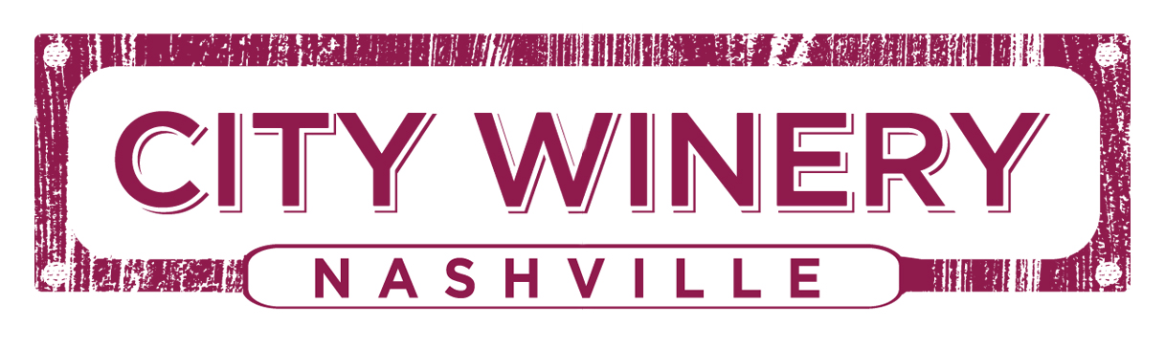

FACT SHEET

Opened October 2014

Location 609 Lafayette Street
Nashville, TN

Telephone 615-324-1010

Website www.citywinery.com

Founder/CEO Michael Dorf

Chef Kristin Beringson

Wine Director David Mensch

General Manager David Richter

Marketing Director Carla Antonelli

Cuisine We have created a Wine Inspired menu that is Regionally Influenced by the cuisines of the Mediterranean – Italian, French, Spanish, and Middle-Eastern cultures, as well as Locally Sourced to pair with our list of house-made tap wines and 400-bottle international wine list, to be enjoyed by you and your friends before and during the concert as well as in the restaurant.

Design The former 30,000 sq ft SoBro warehouse has been transformed into a contemporary urban winery and state of the art music venue. The décor evokes the romance of being in wine country, from the exposed stainless steel fermenting tanks and French oak barrels, to the aroma of fermenting grapes during harvest and embellished with architectural elements like barrel tap handles and barrel stave accent walls. City Winery’s sound design is provided by Meyer Sound, a leader in the world of live performance technology, for overall delivery of the best musical experience.

Reservation Options Phone: 615-324-1010
Online: http://www.citywinery.com/nashville

For events, tickets are available at the box office Mon.-Fri. 11am-6pm
Email: nashville@citywinery.com

Capacity Music Venue Capacity: 300-325 seated with beverage and dining service
Main Restaurant: 125 seated
Private Dining Spaces – capacities vary from 30-60
Outdoor Mezzanine/Lounge areas available for private events
Barrel Room available for private events

Venue Hours Monday-Thursday - Dinner 5:00p-10:00p
Friday & Saturday - Dinner 5:00p-11:00p
Sunday - Dinner 5:00p-10:00p
**Bar stays open daily 1 hour after kitchen closes
** Music venue dining is typically available 2 hours prior to a show and during shows. Always refer to ticket confirmation for specific details.

Restaurant Hours Monday-Thursday = Lunch 11:30am-2:30p, Bar menu 2:30p-5:00p,
Dinner 5:00p-10:00p
Friday & Saturday = Lunch 11:30am-2:30p, Bar menu 2:230p-5:00p, Dinner 5:00p-11:00p
Sunday = Lunch 11:30a-2:30p, Bar menu 2:30p-5:00p, Dinner 5:00p-9:00p
**Bar stays open daily 1 hour after kitchen closes**

Winery & Barrel Room Nashville’s first fully operational winery, City Winery Nashville produces and serves house wines from grape varieties sourced from the finest vineyards around the world including California, Oregon, Washington State and as far south as Argentina. The restaurant located at the ground level will house fourteen tap wine options, preserved in stainless steel kegs that are stored in a temperature-controlled environment for optimum freshness in each glass.

This system, developed by City Winery’s master wine maker David Lecomte, has been recognized for its “green” approach with no need for bottling, corks or labels and therefore minimal impact on the environment

Coming in 2015 over 14 varietals will be produced inside the walls of City Winery Nashville and will be available on tap or in bottle onsite or to go and enjoyed on the run. City Winery offers wines available on tap and from the bottle by the glass as well as its list of more than 400 wines sourced from all around the world.

Barrel Room Hours 5-7pm “Crush Hour” reduced pricing on tap wine

VIP Lounge A mezzanine level bar and seating area together with an attached skybox provides an additional viewing and service experience where guests can enjoy a unique perspective of the concert and the venue.
The skybox can also double as a private meeting room.

Private Event Space We believe that private events and City Winery are the perfect pairing - combining guests with a passion for food, wine, and music with a venue that blends a fine dining culinary experience with a relaxing wine country ambiance. Our sole endeavor is to provide flawless hospitality while indulging your guests’ senses and executing a memorable event. We offer food & wine classes along with other programs including hands-on wine blending with our winemaking team. City Winery’s flexible space can be crafted to fit your event needs. Let us integrate all that we have to offer to give your guests a truly memorable experience. City Winery Nashville can accommodate private events that range from five people to 2,000 – there are countless ways to utilize this space.

Transportation By Bus: MTA Routes 1, 84, 86 and 96

Parking Valet parking available $7/public and free for City Winery VinoFile members, limited spaces available in the City Winery lot for those members; parking also available in the Music City Center Garage.

Credit Cards Visa, Mastercard, American Express, Discover

Media Contact Nicole Pope, Lisa Chader
NPG PR
Nicole@npgpr.com; Lisa@npgpr.com

